A000-Asia-Nepal-Headdress-Feather- **early 1900’s**

**Case No. 15**

**AUTHENTIC GUARANTEED NEPAL SHAMANS FEATHER HEADDRESS, 8" , YEARS OF RITUAL USE-USED IN RITUALS CORRECT PATINA RICH FROM YEARS OF USE, VERY WORN FROM USE,early 1900’s**

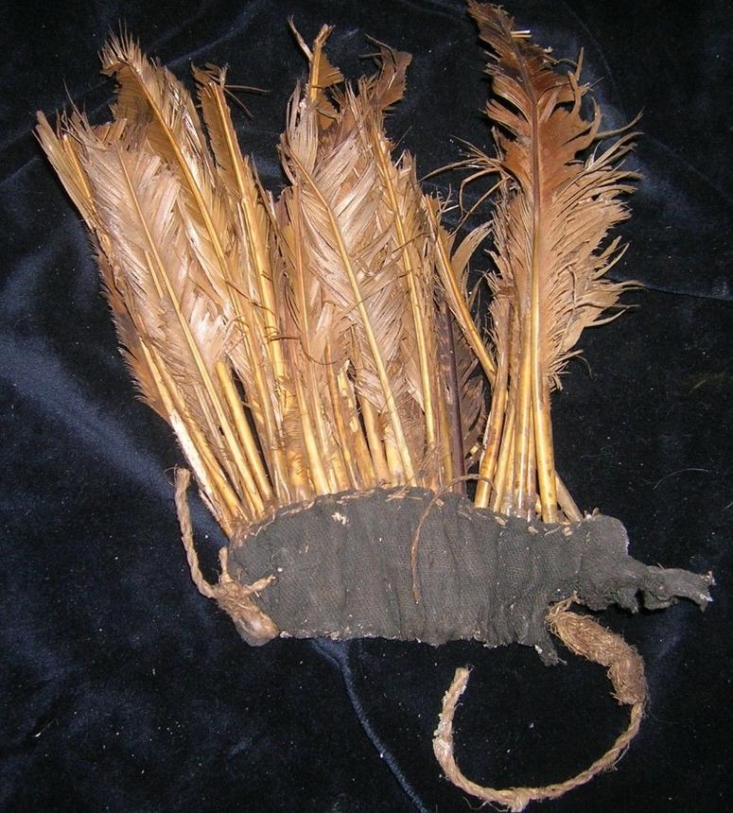

The Nepalese shamanic sources of power come from honoring Mother Earth and the spirits of the place where the shaman performs his ceremonies. The shamans must call on the guardian spirits and deities who inspire him; the keepers of the earth, snowclad mountains, trees, rivers, lakes, and medicinal plants. The sacred hidden language of the land is felt in the form of rhythms, vibrations and warm and cool sensations in the physical body. Understanding this language, the shaman has to honor the spirits of the place and ask their permission. If the place is spiritually dead or some malignant spirits have taken over, the shaman must first revive the balance or fill in the gap of what is missing by calling on the spirits of the place.

Among most Nepalese people, it is believed that the 'soul' never dies but transmigrates from one body to another through many cycles of death and rebirth. The culture believes that while the physical is a gift from our blood relations, the soul we have is directly inherited from our past life experiences. As we are part and parcel of all our ancestors, the ancestral deities are a strong source of power and protection for the Nepalese shaman. **Bloodline ancestors from the father's lineage and milk line ancestors from the mother's side are equally important**. Without the ancestors’ blessings and help, not only are shamanic healings difficult, but loss of equilibrium and imbalances are likely to arise in everyday lives.

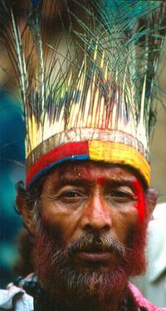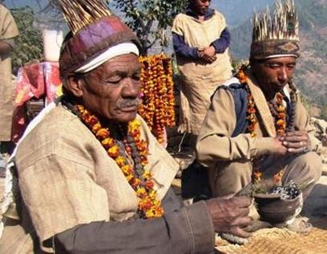

While the term Dhami or Jhankri are used all over Nepal, some ethnic groups have unique terms for the shaman. Some examples include:

* Tamang people: Bonpo
* Gurung people: Khyapri
* Kham Magar people: Ramba/Rama
* Rai people: Bijuwa
* Limbu people: Phedangba
* Tharu people: Ojha

In research conducted by the university in the late 1970’s it was noted that for every shaman there were 70 people that the shaman cared for, where as a each medical practitioner was responsible for over 27,00 people. This meant that far more people received individualized care by a shaman than could be seen by a medically trained person. Today, thanks to the aggressive introduction of conventional care and religious conversion, far fewer people are seeking the services of shamans that in the past.

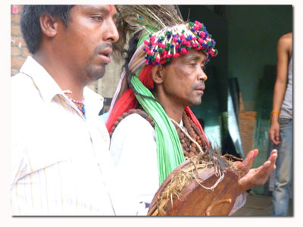

For instance, due to influences by other traditions, people in Nepal now have more choices when seeking seek spiritual help. Along with shamans, people may consult a Hindu Brahman pandit, a Buddhist lama, a Christian minister or priest, an Islamic spiritual healers(pir) or other spiritual counselor for assistance.

This “modern” transition is tragic as human beings are no longer attending to being in harmony. For most of our collective human past, people nurtured very good relationships with nature and all that is created. Our ancestors made offerings, revered their ancestors, honored Mother Earth and understood that caring for the plants and animals was a part of being and living a harmonious life. The result is that many human beings feel fractured, fragmented and disconnected from the Source.

The role shamanism can play in healing our collective “Fall from Grace,” is to help restore people to harmony, to mend the tears in the fabric of interrelationships that make and keep us vital, reintroduce individuals to their own preciousness and help people to remember the profound sacredness of nature. In many ways, it is our oldest spiritual connection that holds the biggest hope for a bright future!

1 Essays on the Ethnology of Nepal and South Asia, Kathmandu 1983, A.W. Macdonald.